EXPERIMENTAL DESIGN OF THE ADAPTIVE BACKSTEPPING CONTROL TECHNIQUE FOR SINGLE PHASE SHUNT ACTIVE POWER FILTERS
ABSTRACT
In this study, a cascade two-loop non-linear controller is developed for single-phase shunt active power filters which is robust and stable in a wide range of output current and DC-link voltage changes. A variable structure proportional–integral controller is designed to regulate DC-link voltage in the outer loop. Also filter output current is controlled in the inner loop using adaptive backstepping approach. All of the model uncertain parameters are estimated using designed estimation rules. By introduction of suitable Lyapunov functions, proposed controller stability is investigated using Barbalat lemma. Grid reference current is calculated indirectly using a phase-locked loop circuit according to DC-link voltage error. Designed active power filter has been implemented using TMS320F28335 digital signal processor and practical response of the developed controller is studied in some tests. It is shown that the proposed controller is able to eliminate harmonic components of the local load current with a fast dynamic response. Also, compensation capability of the designed non-linear approach is compared with sliding mode controller in similar conditions.

BLOCK DIAGRAM FOR PROPOSED SYSTEM
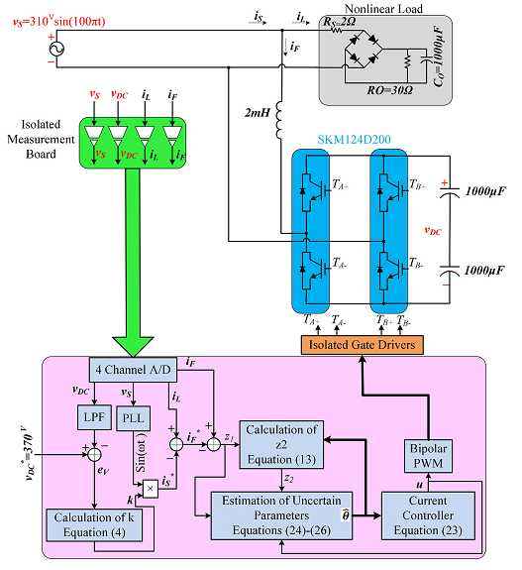
Fig. 1. Implementation of the proposed controller in single-phase SAPF.
DESIGNG SOFTWARE AND TOOLS:
MAT LAB /SIMULATION Software and simu power systems tools are used. Mainly control system tools, power electronics and electrical elements tools are used.

